T1’s Faker
By : Aaron dukay
The digital pillar I'm promoting is ”Leadership”
Leadership out of the 4 pillars can be considered as the hardest to do.
Why? Because kindness, integrity and perseverance are all important, but only in leadership, you use all the pillars and be able to not only lead yourself, but others.
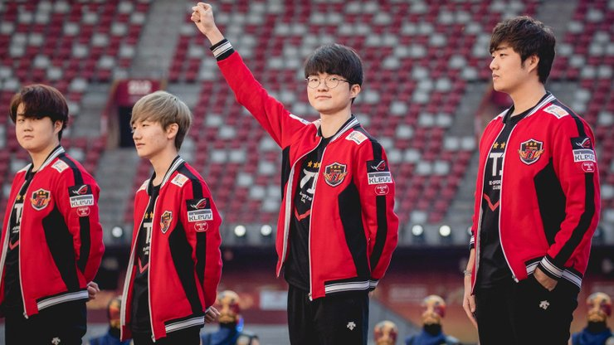
Lee Sang-hyeok (이상혁) also known as Faker is a prime example of leadership as he has evolved from just being the number 1 guy on his team to utilizing and encouraging his teammates.
This is very apparent in the way Faker plays League of Legends nowadays. From building a team around his ability to now complementing each player's playstyle.
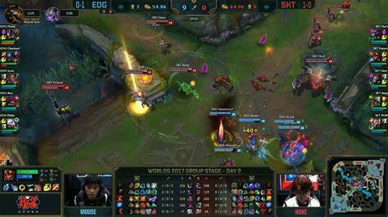
“Faker‘s shockwave will find them all!“
This pillar of leadership is important to me because I want to set an example to my sibling and others on how to make a positive impact online.

