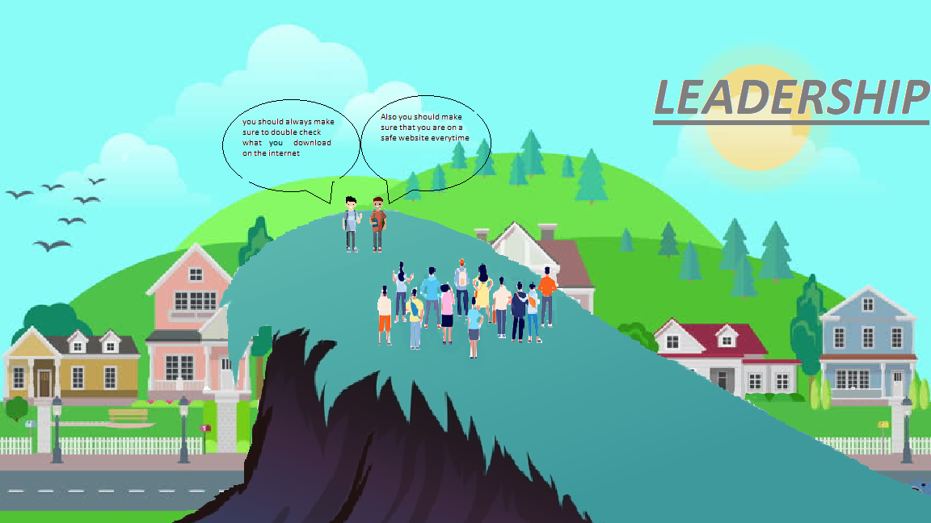This Logo represents Leadership, Leadership is a process of social influence, which maximizes the efforts of others, towards the achievement of a goal. I made this logo to show that being a leader doesn't matter about age or race, there can be more than one leader as well. I personally use leadership online when I am playing video games and I choose to be kind and make people follow my actions as well so they can be kind and respectful too. Leadership is important because it shows how a person really is, for example if they can handle a serious situation and lead people to the right path, leadership also helps your online reputation because without being a leader people won't really trust you with certain stuff and they will think you aren't really reliable and helpful.

