The 4 Pillars Assignment
Digital CHARACTER IN ACTION (CIA)
The goal of this assignment is for you to reflect on being a positive digital citizen while considering one of the four pillars that guide us at Terry Fox:
- Kindness/Compassion
- Integrity
- Leadership
- Perseverance

Perseverance
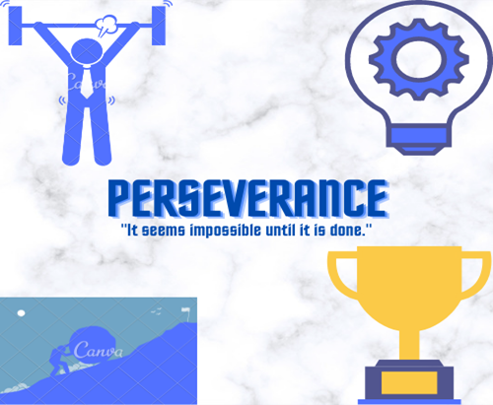
- Describe the digital pillar you are promoting:
I am promoting the perseverance pillar. I am promoting the pillar because I think perseverance is a really big thing in life and I think it really is a good habit to learn. It helps you learn and grow and become a stronger you.
- Connect and explain how you or someone you admire online has applied this pillar to their digital life:
I have applied this pillar in my life by learning and growing in soccer, school, and my social skills. I have applied it in soccer by learning my foot skills and moves better or I got better at checking and shooting the ball. And I only did that by persevering and working harder at my goal. Same thing with school, I just started to focus more and started to get my work done all the time and if I needed help understanding I would ask someone to help me. And with social skills I just worked harder at being able to talk to someone I didn’t know or really didn’t talk to. I got to all these points by working harder and persevering if there were any challenges I faced.
- Explain why this pillar is important to you in creating a positive online reputation:
It is important to me for creating a positive online reputation by being able to show your perseverance online through social media apps and getting feedback on how to persevere more or how well you persevered. Or if you have someone say something about you online that isn’t true you just persevere to show how that one thing isn’t true.

