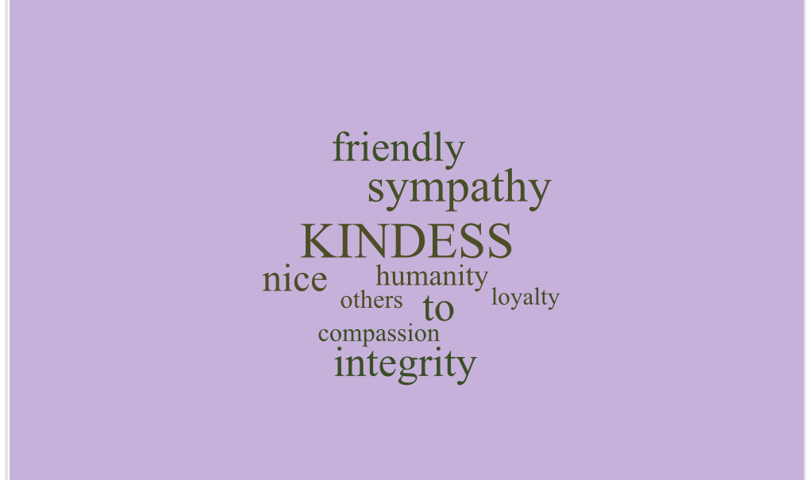
My digital pillar is kindness, it was about caring about other people and not putting people down and giving positive comments.
I always make sure I am kind online and not being rude because you never know how the other person is feeling.
It is important because if you are not kind it hurts peoples feelings and gets you in troubles

