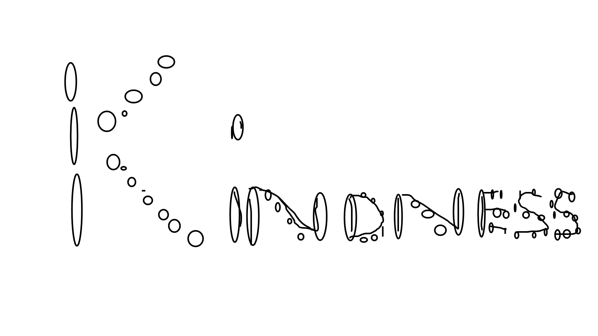
I am promoting the pillar, "Kindness”
I’ve applied kindness to my digital life by saying kind words to others and asking them about how they feel about their lives.
This pillar is important to me as I believe that kindness is something that I, as well as everyone else, should always be expressing to others for a positive reputation online. Kindness is what people want and what people thrive off from so I think that everyone should be expressing kindness more than anything else

