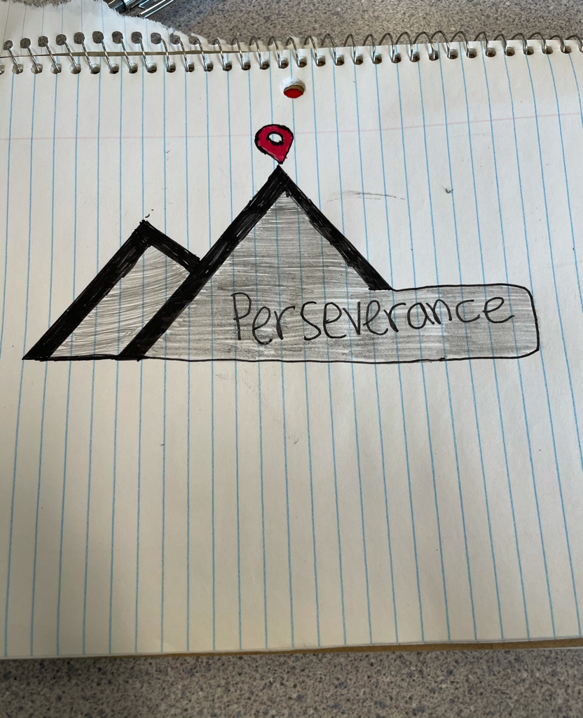

This logo/pillar represents perseverance due to the fact that you need to never give up to reach the mountain top. My logo is a simplistic design with a strong message.

I’ve applied this pillar by biking up a mountain. It was steep, had a nice view which was breath-taking, literally.

This pillar is important to me because it shows what you can accomplish with persevering through tough times. No matter what, never give up.