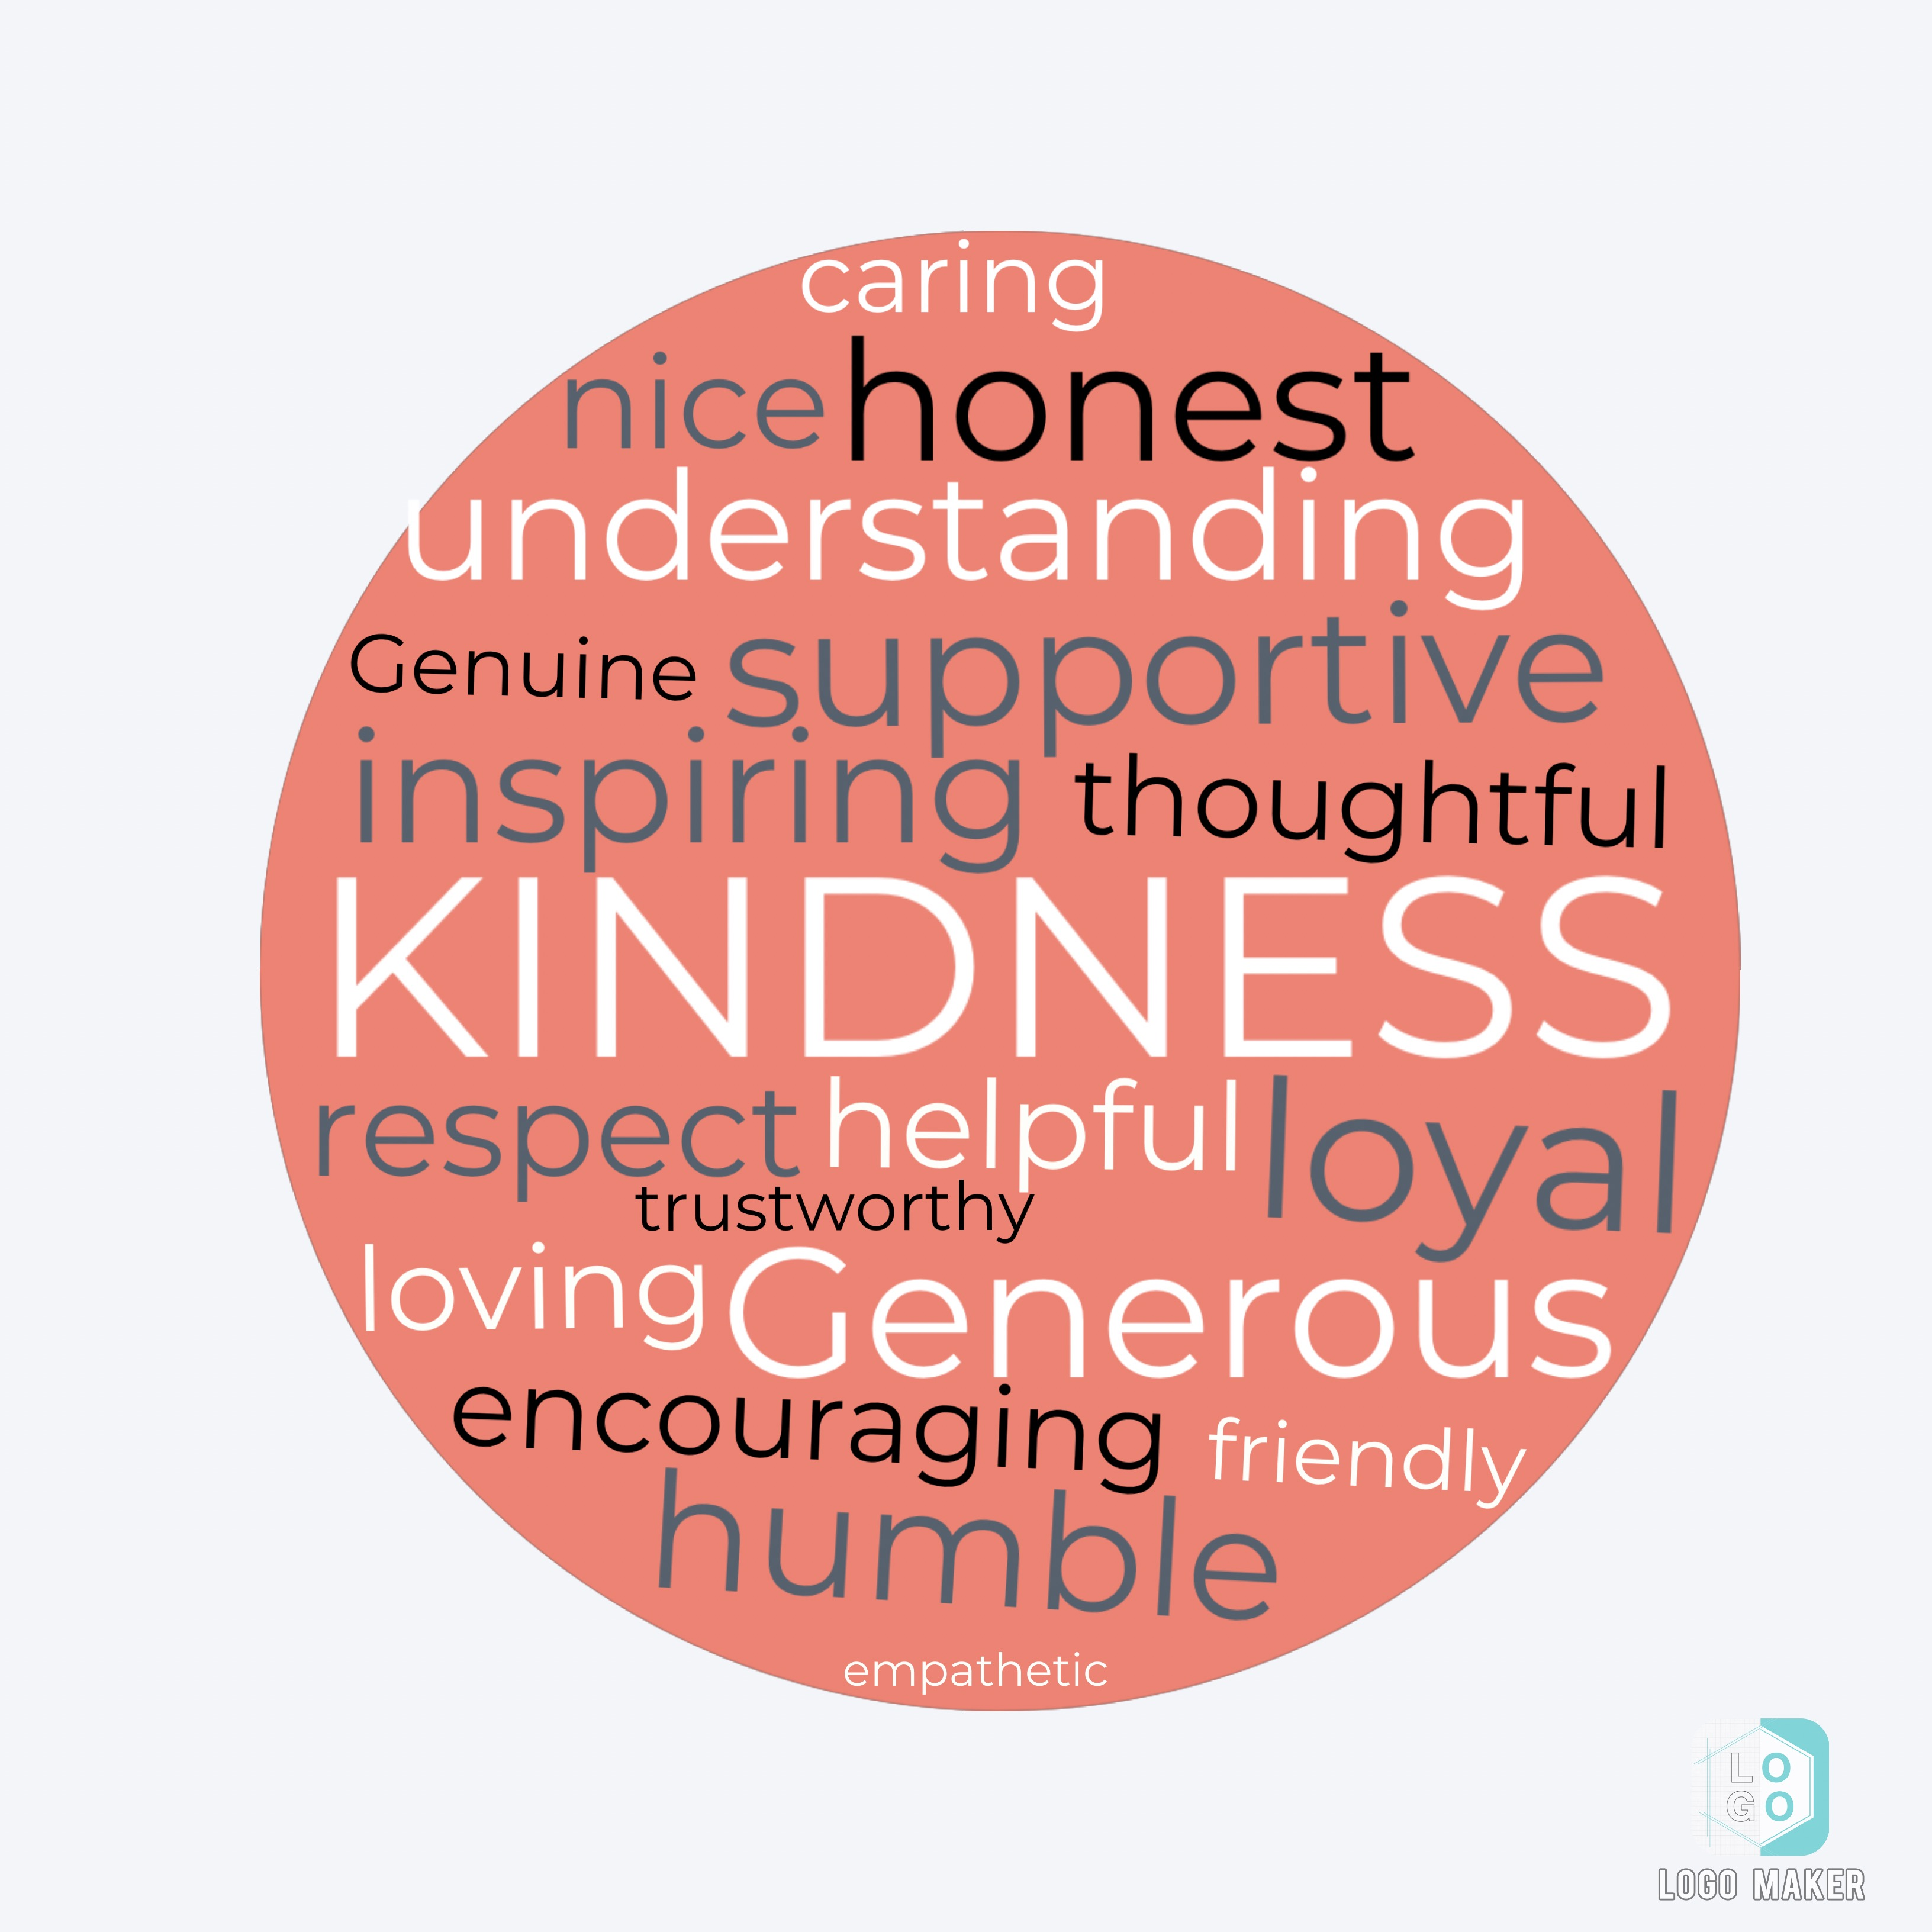
• This symbol represents kindness. The words around it are the the characteristics that a kind
person should have. The different color represent the different type of people, and kindness that is portrayed in the world.

• I show kindness by, reposting important things like missing people or go fund me pages. I also comment positive things on peoples posts, so then they can feel better about themselves.

• Being kind to people is very important, because being kind makes people like you more, and it makes a good impression for you on other people. It makes people feel good about themselves, and it also makes you feel good about yourself.

