Kindness
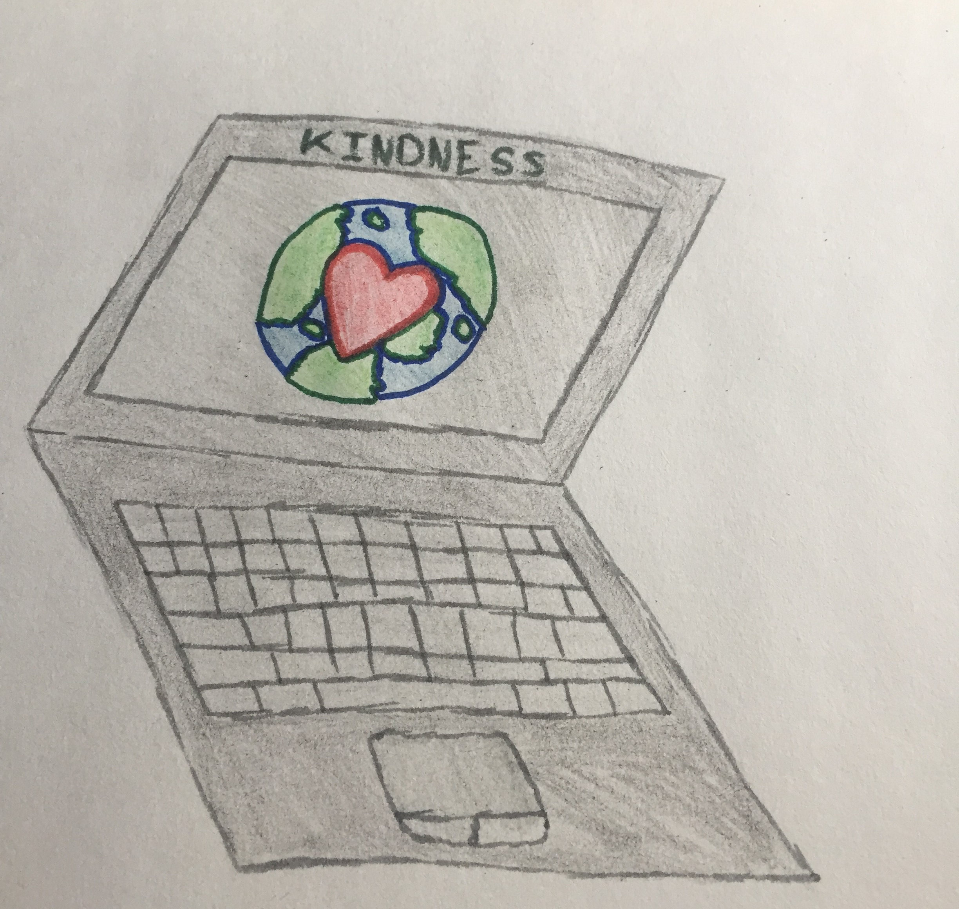
Sarah Munro
I am promoting kindness, kindness I very important skill to have online and in person. It is a skill that I believe everyone has but not very one uses. As one pointed out to me, we are all was so kind to people who are dying because we want their last days on earth to be filled with happiness, but we never really know what day somebody's is last day because anything can happen from car accidents to suicides. We might be virtual but the does not give anyone and excuse to be rude and un-kind online.
Someone that I admire who shows digital kindness is Charli D’Amelio. She shows digital kindness by bringing awareness and talking about issues in the world like “Black Lives Matter” and “Body Image Movements”. She also takes the money that she makes and gives back to the people in need, like special needs fundraiser, the Norwalk Hospital and The American Dance Movement to name a couple.
This pillar is important to creating a positive online reputation because without kind words and kind people online, online becomes a very negative place. You may think that you can say whatever you want because you are online and hidden behind a screen. If you are unkind online future employer will probably not want to higher you. Being unkind online will not only hurt them but it might hurt your future.

