The 4 Pillars Assignment

Digital CHARACTER IN ACTION (CIA)
The goal of this assignment is for you to reflect on being a positive digital citizen while considering one of the four pillars that guide us at Terry Fox:
- Kindness/Compassion
- Integrity
- Leadership
- Perseverance

Task 2: Demonstrate your understanding of “Be Like Terry”

Create an infographic or small poster showcasing your uniquely designed logo that PROMOTES one of the Character in Action pillars.

Your goal is to communicate to students: How to ‘Be Like Terry’ in a Digital World
- Design and create a unique logo for your chosen pillar (draw by hand or use a digital app of your choice to create)
- Describe the digital pillar you are promoting
- Connect and explain how you or someone you admire online has applied this pillar to their digital life.
- Explain why this pillar is important to you in creating a positive online reputation

When you finish Task 2:
To achieve a 4/4 you need to place your work on your website and share the link in Teams:
- Embed your work on your WordPress website on the CHARACTER IN ACTION page
- Instructions for embedding your work to your website are below.
- Once your page is ready to be graded, copy the link to your Character In Action page and add it to the assignment in Teams.
- “Turn in” this link on Teams (thru Assignments).

How to embed your document onto your webpage.

- Log into WordPress at http://terryfox.sd43.bc.ca

Note: WordPress is the application you used to create your About Me Page.
- Use your first name, followed by the first letter of your last name, followed by the year you graduated. Ex. hannahm2020  - Your password is the same password you use to log into the computer. | 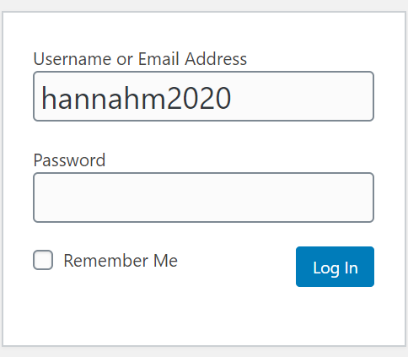
- Hover over ‘My sites’ at the top left of the page and click on your name’s blog
- Proceed to your dashboard, find Pages on the left-hand side and click ‘All Pages’.

- Click on the “Character in Action” page that was made for you | 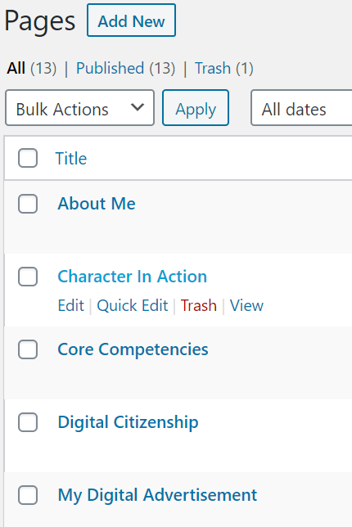
- Customize and edit your page here. | 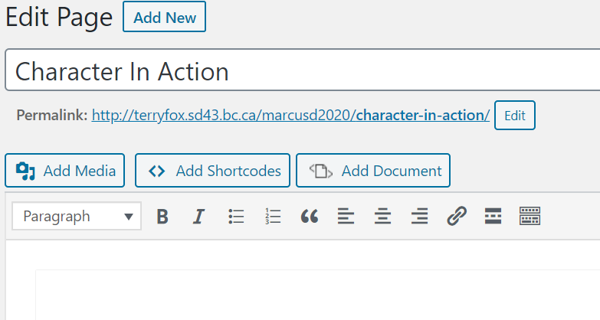
- Click on the button – ‘Add Document’
- Click on upload document and find your saved document. Upload your document to your media library.
- > Find the document you uploaded into your media library and click on it

> Click on select and decide how large you want the document to be. We recommend the width to stay at 100% and for the height to have around 550px
- Click on insert, you will see a bunch of code that shows up. Preview your page by clicking on the preview button at the top right.

- Once you have embedded the document you can update your page. Click on the permalink at the top of your editing page and view what your page looks like.

- Copy the permalink or address to your Character in Action page (not the editing page) and paste this into Teams. Don’t forget to do assignment reflection as well!

Assessment Rubric:
1 – Emerging | 2 – Developing | 3 - Proficient | 4 – Extending
Demonstrates an understanding of a digital pillar. | Able to connect the digital pillar to achieving a healthy and positive digital environment. | Expresses personal views and perspectives as a positive digital citizen.  Aware of how a positive online reputation can be an asset that should be developed and managed effectively to support aspirations. | Assignment is proficient and is effectively and creatively displayed on student website.

App suggestions:
Canva
Piktochart
Sketchpad
PowerPoint

