Media Awareness Assignment Part II
The goal of this assignment is to share your thoughts about media awareness (Fake News/ Misinformation)

Assessment Instructions:

Option 1: To receive a 1 or 2, write your answers to the questions below and click turn in.

Option 2: To receive a 3 or 4, create an audio recording of your answers to the questions below (approx. 1 minute). Add the audio file to your website, complete the reflection and share the link in Teams:
Task: Answer the questions below and decide if you are doing option one or two above.
Questions to answer:
- What is disinformation (Fake News)?
- False or misleading information that is spread deliberately to cheat.
- How does disinformation impact a community?
- Disinformation impacts community as: Impacts on health, racism ideas, fear of something severe, bullying and violence against innocent people.
- Give an example/share an experience of how disinformation impacted you or a community.
- There is an app called WhatsApp, my parents got a message about having a free holidays to another country when we were in India, I guess that was a fake news.
- How would you help your fellow classmates identify and stop the spread of disinformation?
- They can get to the website, check in more detail and if they found nothing about it means its fake news.
For Option 2:
Audio Recording Resources: You can use a phone recording app, try anchor.fm or any other podcast app that you are able to access.
- Embed the audio clip containing the answers to the questions on your WordPress website on the DIGITAL CITIZENSHIP page
- Instructions for embedding your work to your website are below.
  - Add a written description of your audio file to enhance the page
  - Add images to make the page more appealing
- Once your page is ready to be graded, copy the link to your Digital Citizenships page and add it to the assignment in Teams.
- Complete the reflection assignment on Teams.
- “Turn in” this link on Teams (thru Assignments).
Learning Curricular Competency Critical and Creative Thinking

Proficiency Level Description | Reflection Questions for Students:
1 - Attempting  Uses digital tools and resources to accomplish the assigned tasks. | Describe the digital learning goal(s) in this assignment.  - We should be organized of what we are writing.  - It should be appropriate.  - Skills for a rapidly changing world and markets can be developed.  - Motivation for learning may increase when students should have a choice to create their own portfolio.
2 – Developing  Able to Identify digital tools, apps, and procedures used when they created the message. | Identify the digital tools, apps and procedures you used to complete this assignment.  Google
3 - Proficient  Explores, experiments, and innovates while generating imaginative approaches, techniques, artifacts, or content through the application of digital literacy skills. | Compare the effectiveness and efficiency of the podcasts  The difference between these two can be say in shortly and sweetly while being effective is about doing the right things and efficient is about doing things right.
4 – Extending  Able to justify and reflect on the selection and use of digital tools based on their efficiency and effectiveness.  Add your audio to your Edublog Portfolio. Please provide the link in Teams. | How could a digital platform be important? What did you consider when curating your website? (Did you simply put your link onto a page?)  It has a faster time to launch, automated setup. It brings together vast communities of partners, communities etc.
What grade do you think you have achieved on this assignment?
Out of what… It does not show from how much so that’s why I don’t know.

How to embed your document onto your webpage.

- Log into WordPress at http://terryfox.sd43.bc.ca

Note: WordPress is the application you used to create your About Me Page.
- Use your first name, followed by the first letter of your last name, followed by the year you graduated. Ex. hannahm2020  - Your password is the same password you use to log into the computer. | 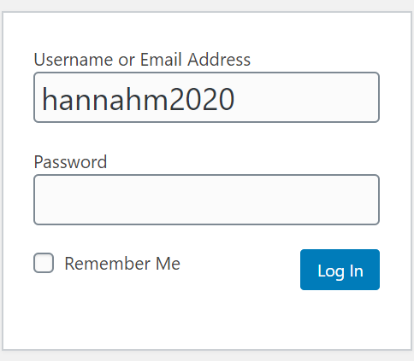
- Hover over ‘My sites’ at the top left of the page and click on your name’s blog
- Proceed to your dashboard, find Pages on the left-hand side and click ‘All Pages’.

- Click on the “Digital Citizenship” page that was made for you | 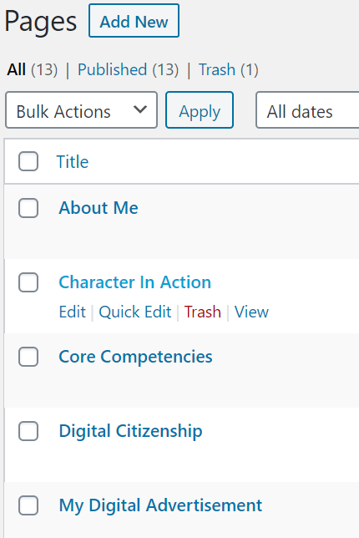
- Customize and edit your page here. | 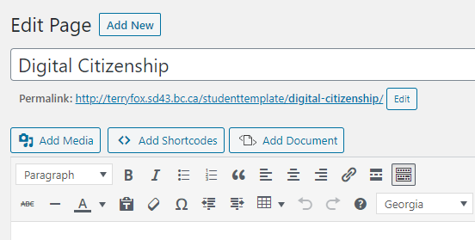
- Click on the button – ‘Add Media’
- Click on upload document and find your saved document. Upload your document to your media library. | 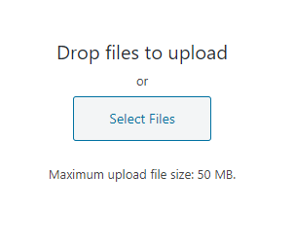
- Click your audio file and click insert to page.
- Once you have embedded the audio file you can update your page. Click on the permalink at the top of your editing page and view what your page looks like.  - Add descriptions of your audio file and a short paragraph to enhance the page | 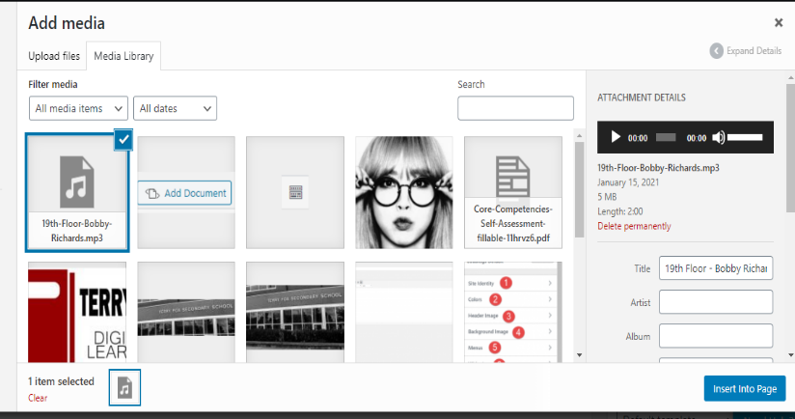
- Copy the permalink or address to your Digital Citizenship page (not the editing page) and paste this into Teams. Don’t forget to do assignment reflection as well!

