4 PILLARS ASSIGNMENT
Siyal

The pillar I selected is perseverance. This was important to Terry because this is what got him through fighting cancer and doing the marathon. The logo I have designed for this pillar is a turtle with a symbol on its back, which represents perseverance:

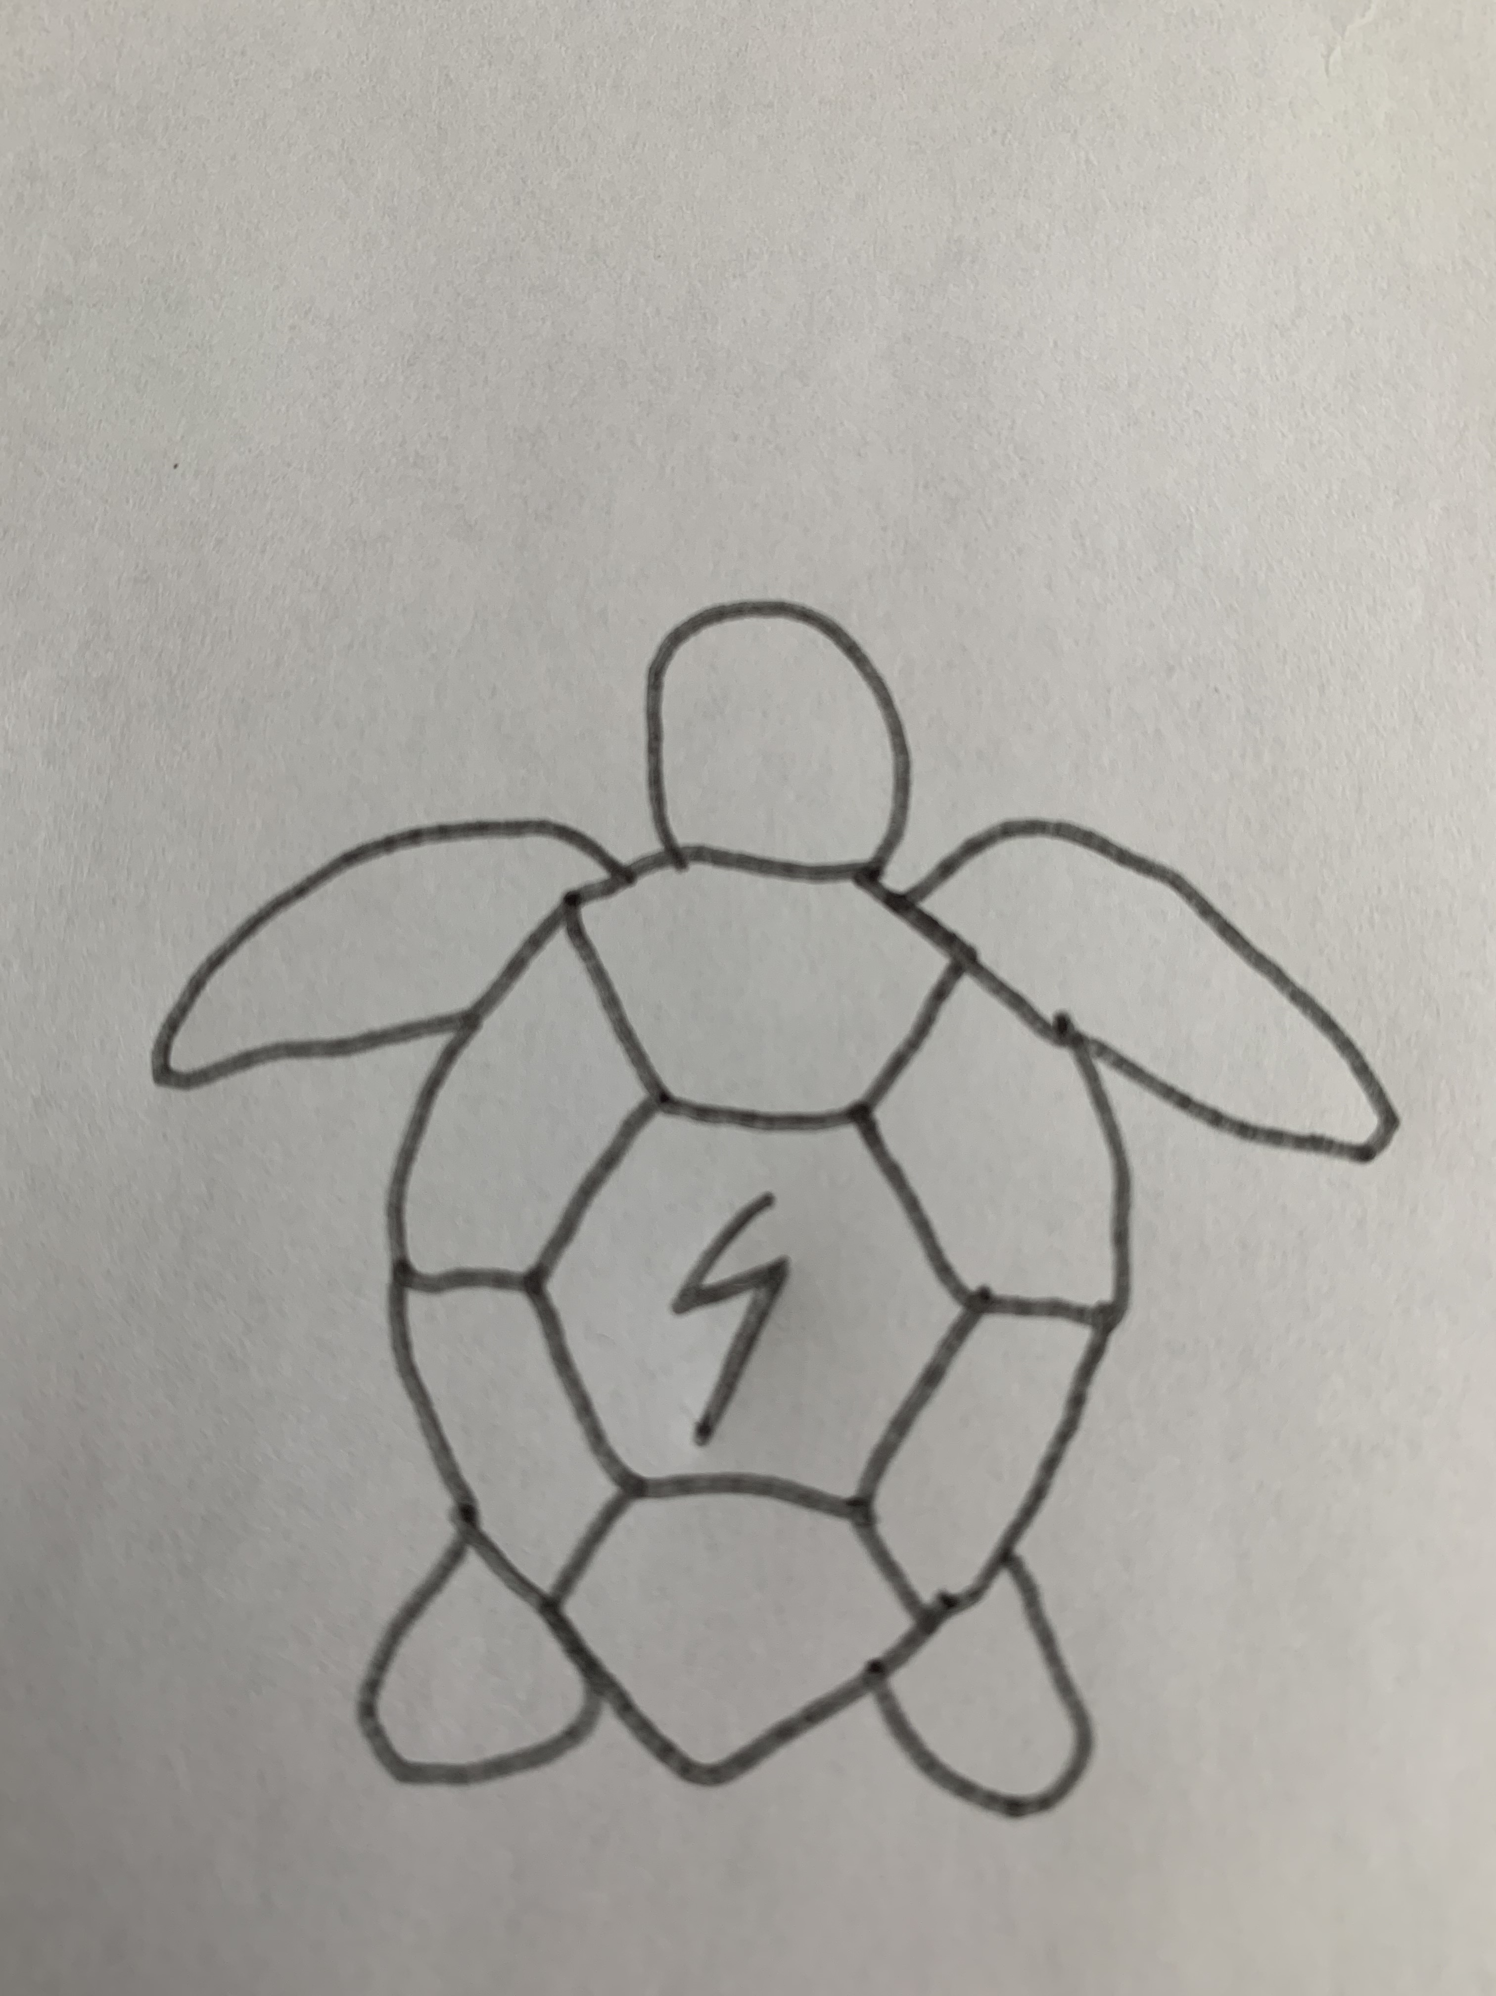

Describe the digital pillar you are promoting
The digital pillar I promoting is perseverance in this logo. The turtle is an animal that may not be the fastest but still gets to where it needs to be. The symbol on its back represents a few thing such as a lightning bolt for speed, The number 5 which would be like a racing number saying that its apart of the race, and the letter S to represent me. Slow and steady wins the race as long as you have perseverance.

A person that also uses perseverance in a symbol is drake. His logo is an owl, which represents wisdom.

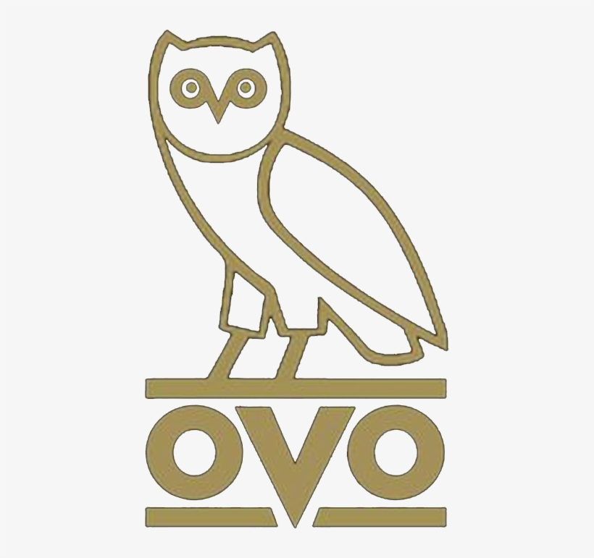

Wisdom is important to perseverance and drake shows this in his music for example gods plan were he explains that he has to stay focused to not let the negativity get him down.

Explain why this pillar is important to you in creating a positive online reputation
Perseverance is important to me because it applies to all parts of my life and to everyone’s around me. Such as school, sports, and what ever challenges life brings.

