Task 2: Demonstrate your understanding of “Be Like Terry.”

Design and create a unique logo for your chosen pillar (draw by hand or use a digital app of your choice to create.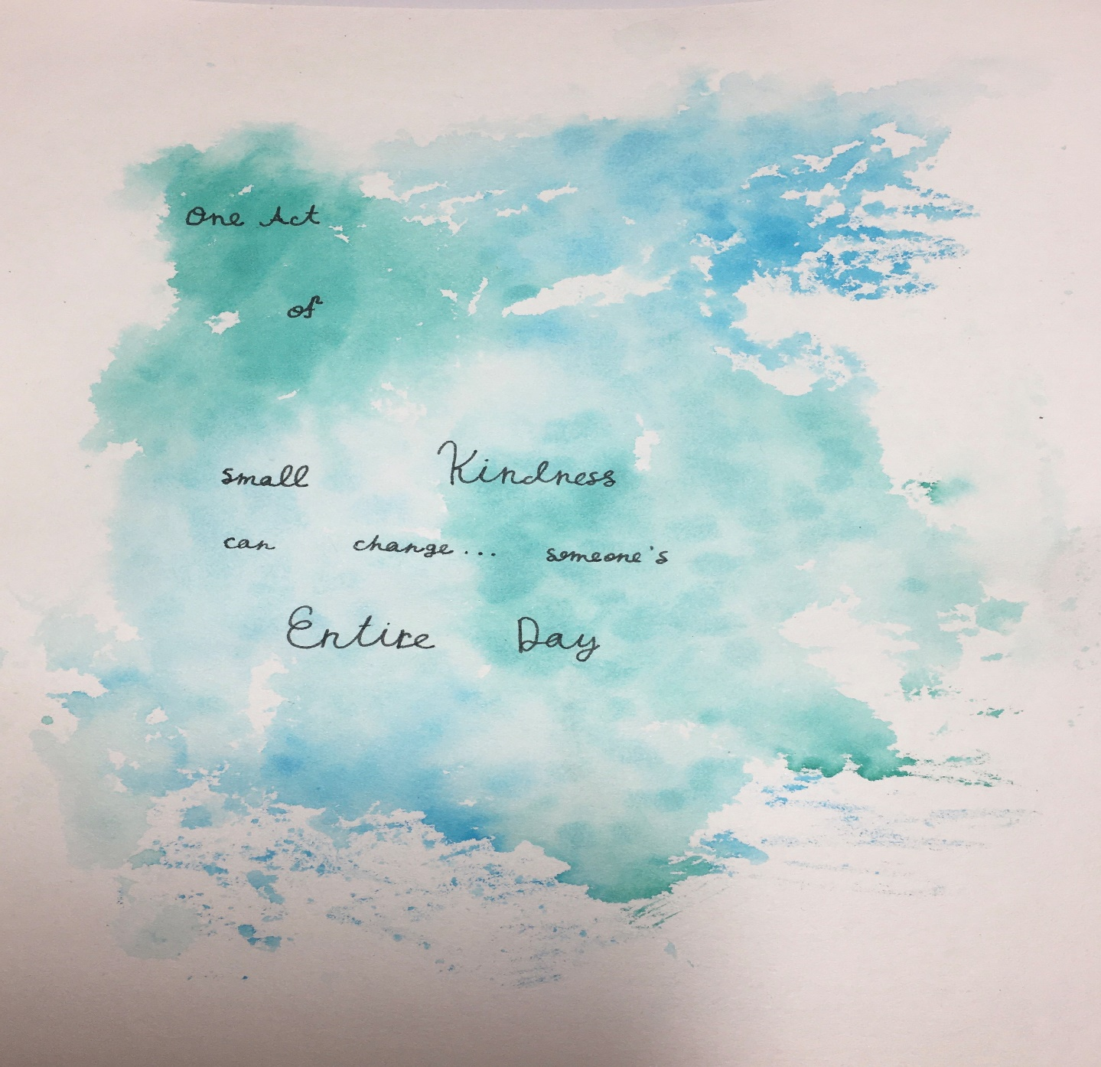
· Describe the digital pillar you are promoting. The digital pillar I am promoting is kindness/compassion. And my logo describes of how one act of small kindness can change someone’s entire day. I know it doesn’t look like a logo and it only has the quote on it, but I want people to understand the meaning of this quote. It is not just a random quote it is a quote that people get inspired, admired, and motivated by, and I just want to remind people to always be kind and respectful to others.
· Connect and explain how you or someone you admire online has applied this pillar to their digital life. I have seen a lot of people that I admire online have applied this pillar to their digital life. But specifically, I have seen videos that promote this pillar. In the video it talks about of how one act of small kindness can change someone’s entire day. In addition, in the video a spoiled boy who wanted the new Ps5 did show two small acts of kindness after his mom taught him a lesson. The video started by him begging his mom for the Ps5. But while that was happening, he spilled juice over his sweater. He took it off and was about to put it into the garbage bin, but his mom stepped in and told him to stop. The boy said, “I still need a new one and washing it won’t help because it’s stained.” In reply his mother said, “Well if you think that, then give it to the homeless man who is five steps away from us and who is shivering from the cold.” She also said that one act of small kindness can change someone’s entire day. So, the boy came up to the man and gave the sweater to him he said, “I know it is stained but I hope it helps.” The man had delight in his eyes he was so happy. He told the boy, “Thank you so much it is so cold here.” The boy went back to his mom with a shocked face and told his mom, “Wow, I didn’t expect that to happen.” The mom then told him to give 25 cents to another homeless woman who was also five steps away from them. His mom gave him 25 cents. The boy didn’t understand of how 25 cents can help someone, but he gave the 25 cents to the homeless woman anyway. He told the woman, “I know its not much, but I hope it helps.” The woman was shocked. She told the boy, “Thank you so much that’s all I needed so I could see my daughter.” She showed him a jar with money inside and said thank you again. The boy went back to his mom and said, “You were right this whole time. Indeed, one act of small kindness can change someone’s entire day.”
I don’t remember the ending of the video, but I did remember one thing, that one act of small kindness can change someone’s entire day.

· Explain why this pillar is important to you in creating a positive online reputation. This pillar is important to me because being kind and respectful to someone/others can not only make them happy and make there day, but it can also make you feel good about yourself. I truly believe that being kind online can create a positive online reptation because there will be no negativity, bullying, etc. And I hope that it can be that way. But it will only become that way if we start being kind and respectful to others online.

